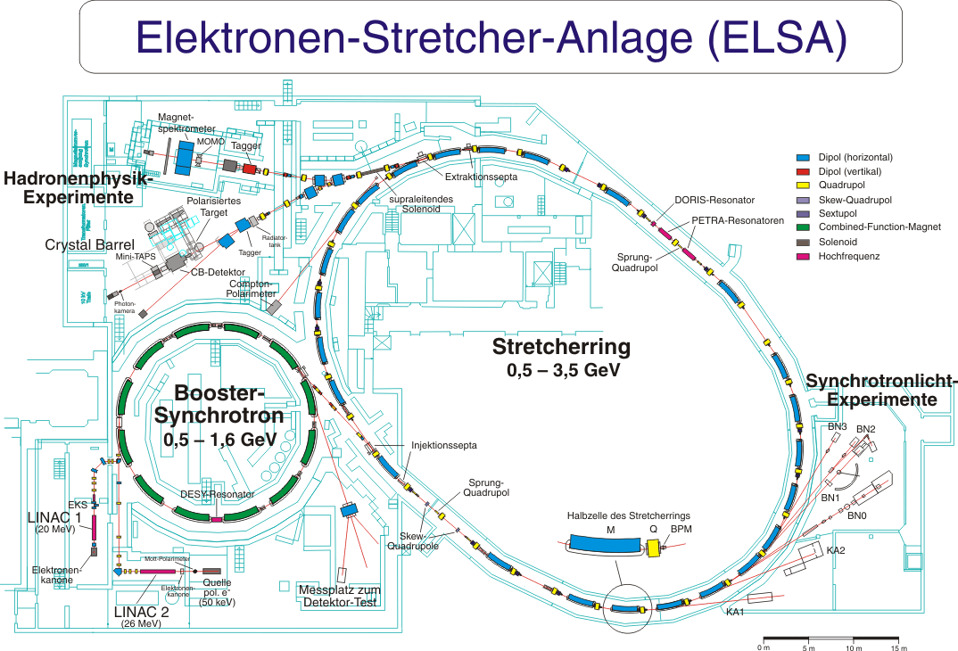
7

B1 _ collaboration

PDF-Version dieses Plans

Beam S

